* Now lets put some validations
* Put in test case level:

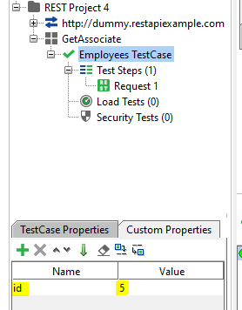

* To get the propertyValue:

context.getTestCase().getProperty("id")

* Codes

def response=messageExchange.response.responseContent

def jsonsl=new JsonSlurper().parseText(response)

def expected=context.getTestCase().getPropertyValue("id")

assert expected== jsonsl.data[4].id

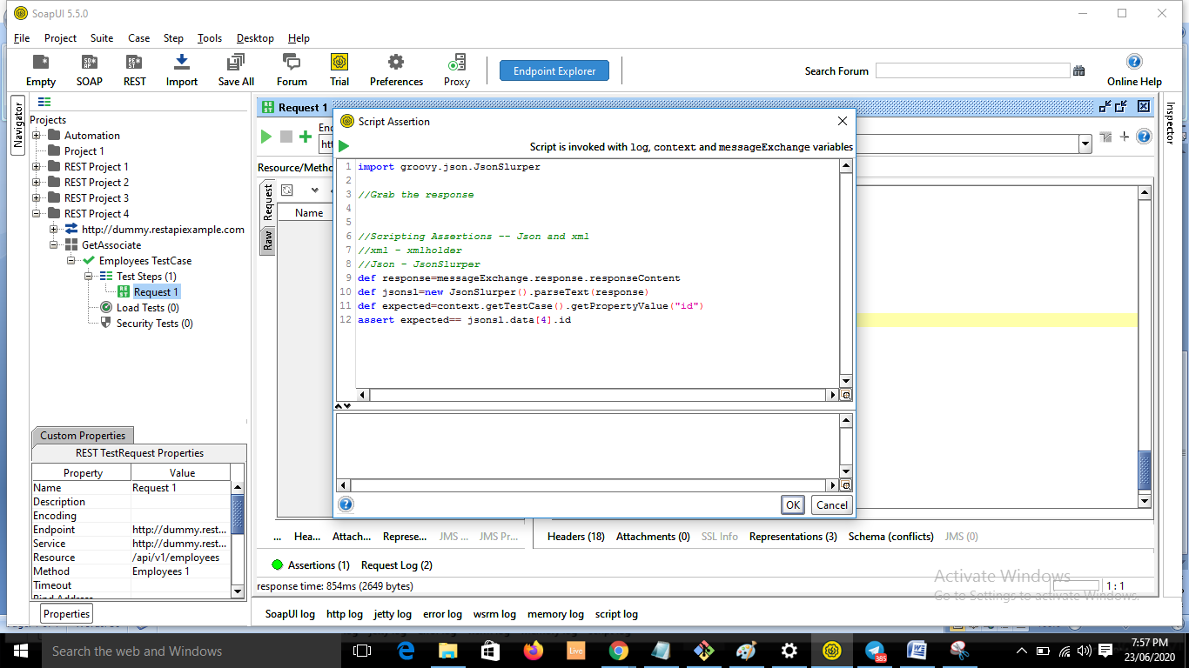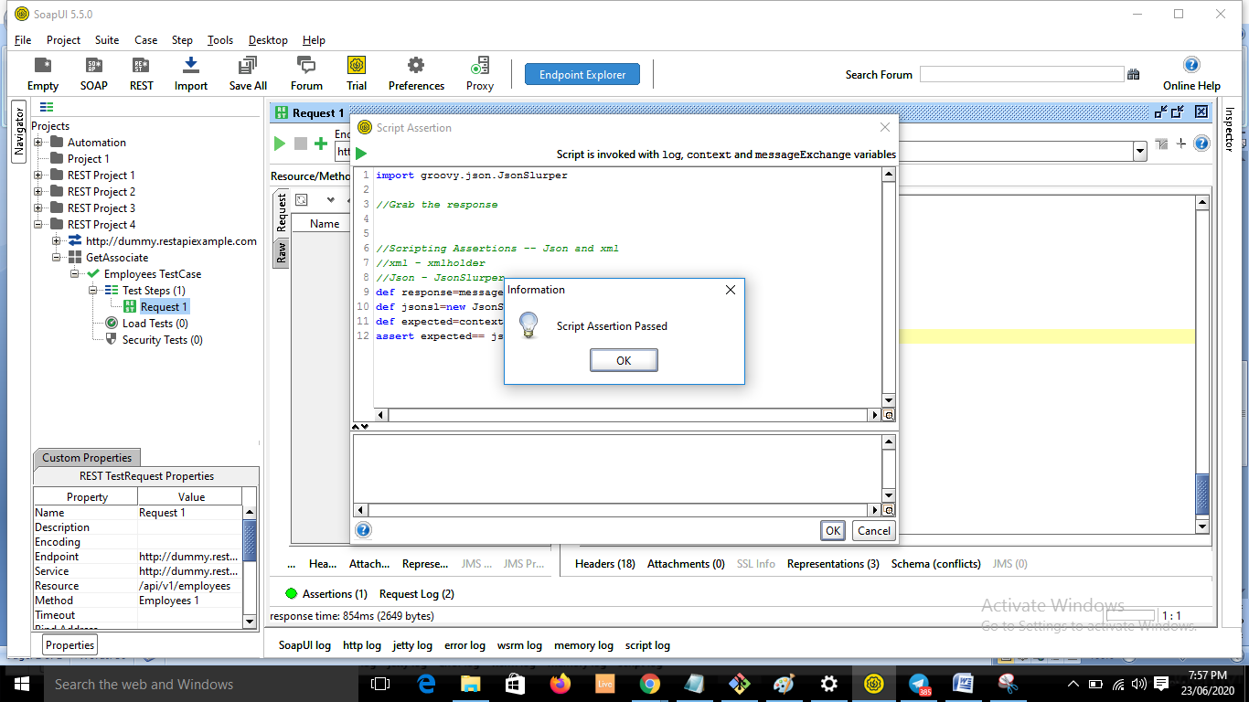

* Run the request now:

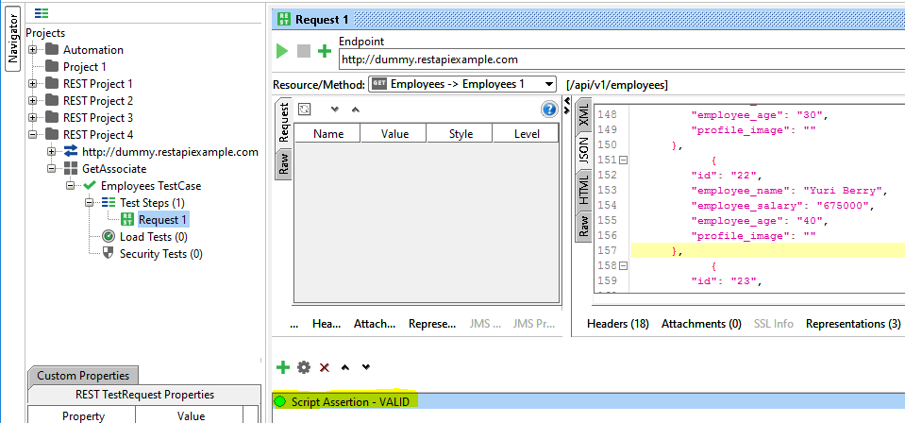

* Another example

